SGS消费品及零售服务

防疫物资检验申请指南

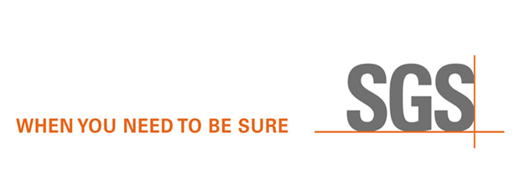

SGS消费品及零售服务

防疫物资检验申请指南

需要出口

口罩、防护服、面罩、手套等防疫物资

请拨打SGS在线客服

咨询相关国际标准认证

及测试解决方案

**4008-855-558**

SGS建议您

登录如下中国医药保健品进出口商会动态更新网站

查询名单

**www.cccmhpie.org.cn**

首先自我查验是否获得

出口到相应区域的国际标准认证

（欧盟国家需要CE及REACH

美国需要完成FDA注册）

未获得

不确定

已获得

SGS将为您

提供

**文审服务**

不确定**CE证书、FDA注册**信息是否准确合规

不清楚文件是否符合进出口清关要求

SGS建议您

咨询当地海关

报关机构

在出货前需要根据客户要求及来样，确认大货产品的外观符合性和一致性

（对大货进行随机抽样并在现场检验产品的数量、包装、标签/标记、式样、颜色、尺寸、手感等外观以及产品的基本功能）

SGS将为您提供

**检验服务**

**请联系SGS工作人员、客户共同确定如下3项要求**

**抽样标准**：ANSI/ASQ Z1.4 - 2003(R2018), GB/T2828, BS6001, MIL-STD-105E ISO2859-1 Single Sampling Plan

**抽样水平**：Level II/客户特殊要求

**特殊检验项目及检查数量**：S/S（针对完成检查后产品将无法正常销售的检查项目）

请联系SGS工作人员申请检验服务

**确认检验日期**

温馨提醒：为确保及时、有效地安排检验，请**提前3-5个工作日**申请SGS检验。如需要修改检验日期，请至少提前一个工作日通知SGS，在检验日期的前一个工作日下午3点后修改检验日期，将会产生检验放空费+实际车票、机票等无法取消的费用，具体费用请咨询SGS服务人员。

需要修改

已确认的检验日期

无法提前3-5个工作日申请

申请加急检验

温馨提醒：

将会增加检验费用

**确认检验地点**

温馨提醒：为确保及时、有效地安排检验，请务必与供应商确定**真实准确的检验地点**。如需要修改检验地点，请至少提前一个工作日通知SGS，在检验日期的前一个工作日下午3点后修改检验地点，将会产生放空费+实际车票、机票等无法取消的费用，具体费用请咨询SGS服务人员。

需要修改

已确认的检验日期、地点

获得报价，完成付款

执行检验

并于完成检验的第二个工作日

出具英文检验报告

**SGS Consumer and Retail**

epidemic prevention materials inspection application guide

You need to import masks, protective garments, protective goggles, gloves and other epidemic prevention materials

If you are not sure whether these documents can meet the import and export customs clearance requirements

Unable to apply 3-5 working days in advance

Yes

No

Not sure

SGS recommends that you visit the following website of China chamber of commerce for import and export of health care products to check the supplier list **www.cccmhpie.org.cn**

Please kindly call SGS online customer service staff to consult relevant international standards certification and testing solutions

**4008-855-558**

SGS recommends that you consult the local customs office

Before shipment, you need to confirm the visual compliance and consistency of goods against the client’s specifications/requirements and approval samples. (It is necessary to carry out random sampling and inspect the quantity, packaging, labelling/marking, style, colour, dimensions, hand feeling and visual of the goods as well as the basic functions of the goods)

If you are not sure whether CE certificate and FDA registration information are accurate and compliant

SGS will offer the **Pre-shipment inspection/ Final Random Inspection (FRI)** for you

Please kindly contact SGS, end buyer to confirm the following three key requirements

**Sampling Plan：**ANSI/ASQ Z1.4 - 2003(R2018), GB/T2828, BS6001, MIL-STD-105E ISO2859-1 Single Sampling Plan

**Sampling level：**Level II/ Special requirements of customers

**Special check list and sub-sample size**：S/S（Some goods cannot be sold after special check）

arrange the inspection, then issue the English inspection report on the second working day after the inspection

Pls kindly check whether the exporter you cooperated has obtained the international standard certification for importing to the corresponding region (The European Union need CE and REACH, and the US needs to complete FDA registration)

Request urgent inspection service

kindly reminder: this will increase the inspection fee

Please contact SGS

for **Pre-shipment inspection /FRI** service

Need to modify the confirmed inspection date, location

SGS will offer the **Document Review Service**

for you

Need to modify the confirmed inspection date

**Confirm inspection location**

kindly reminder: Please kindly confirm **the true and accurate inspection address with the supplier**. When you need to modify the inspection location, please kindly inform SGS **at least one working day in advance**. If you would modify the inspection location after 3:00 P.M. on the working day before the inspection date, SGS will charge the inspection cancelled fee + the actual ticket, ticket and other fees that cannot be cancelled

**Confirm inspection date**

kindly reminder: Please kindly **book SGS inspection 3-5 working days in advance**. When you need to modify the inspection date, please kindly inform SGS **at least one working day in advance**.  If you would modify the inspection date after 3:00 P.M. on the working day before the inspection date, SGS will charge the inspection cancelled fee + the actual ticket, ticket and other fees that cannot be cancelled

Obtain service quotation and arrange payment bill to SGS

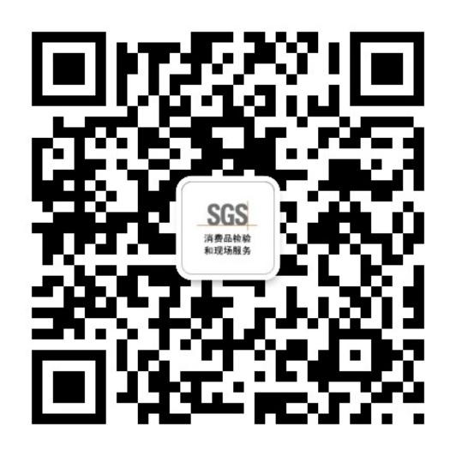

**关注我们，了解更多SGS_FS**

